Furniture Home Inventory Website Technical Foundation Prepared by: Aiman khan Date: 16-01-2025

Hackathon Project

Table of Contents

**Introduction1**

**Tecchnical Requirments** 2

System Architecture3

**API Endpoints4**

Sanity CMS Schema5

Workflow Digram6

conclution7

Introduction

The Furniture Home Inventory Website is designed to provide an efficient and user-friendly platform for managing furniture inventory. This document outlines the technical foundation, including system architecture, API requirements, and data schemas, to create a scalable and dynamic solution.

Technical Requirements

1. Frontend Requirements

- Responsive design for desktop and mobile.

- Pages: Home, Inventory, Product Details, Cart, Checkout.

2. Backend Requirements:

- Sanity CMS for managing products, categories, and orders.

### 3. API Endpoints:

GET /products: Fetch all furniture items.

POST /orders`: Save new orders.

### System Architecture Diagram

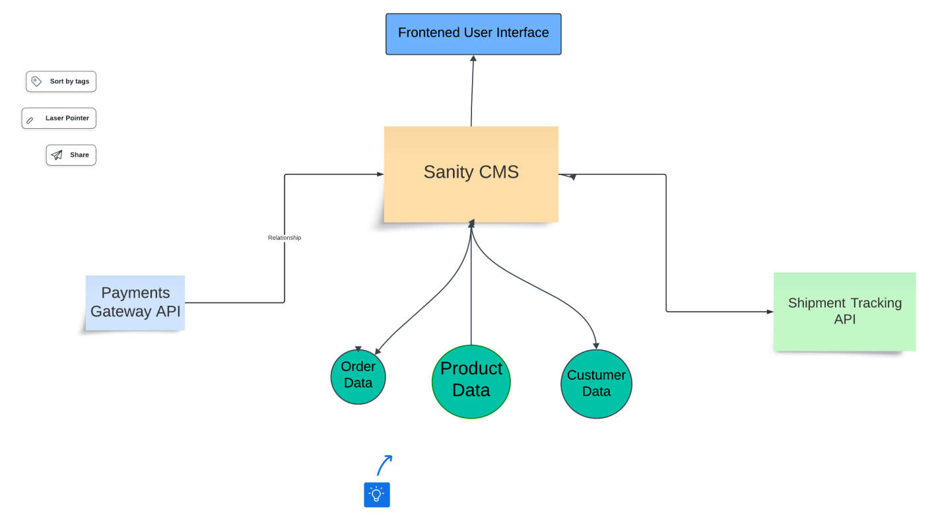

#### FRONTEND

#### BACKEND

HOW WEBSITE WORK IN FRONTEN AND BACKEND

#### BACKEND

#### FRONTEND

#### USER ACTION

#### STORE DATA GENERATE ID

#### SHOW DETAIL FORN

#### CLICK SING UP

#### ORDER CONFORM

#### CHECKOUT

#### ADD CART

#### PRODUCT DETAIL

#### VERIFY CREDENCIAL

#### SHOW LOGIN FORM

#### LOGIN

#### RETURN LIST OF PRODUCTS

#### SEND REQ TO API FETCH PRODUCT

#### BROWSE PRODUCT

#### RETURN PRODUCT DETAIL

#### FETCH PRODCT DETAIL

#### VERIFY ORDER AVAILIBILITY UPDATE CART

#### CONFORM ORDER VERIFY PAYMNT

#### SELECT PAYMENT METHOD

#### DISPLAY CONFORM PAGE

|  |  |  |  |  |
| --- | --- | --- | --- | --- |
| SEN CONFORMATION VIA SMS AND NOTIFICATION |  |  |  |  |

#### FETCH REAL TIME STAUS FROM API

#### STORE IN DATA BASE

#### ASK REVIEW

#### REVIEW

#### SHIPING

|  |  |  |  |  |
| --- | --- | --- | --- | --- |
| **Endpoint** | **Method** | **Purpose** | **Payload (if applicable)** | **Response Example** |
| /products | GET | Fetch all available furniture products. | None | [{"id": "1", "name": "Sofa", "price": 300, "stock": 5}] |
| /products/:id | GET | Fetch details of a specific product. | None | {"id": "1", "name": "Sofa", "price": 300, "stock": 5, "description": "Comfortable sofa"} |
| /categories | GET | Fetch all product categories. | None | [{"id": "1", "name": "Living Room"}, {"id": "2", "name": "Bedroom"}] |
| /orders | POST | Save a new order in the system. | {"customerName": "Aiman", "items": [{"productId": "1", "quantity": 2}], "totalAmount": 600} | {"orderId": "101", "status": "Success"} |
| /cart | POST | Add items to the user's cart. | {"productId": "1", "quantity": 2} | {"cartId": "201", "status": "Item Added"} |
| /cart | GET | Fetch all items in the user's cart. | None | [{"productId": "1", "name": "Sofa", "quantity": 2, "price": 300}] |
| /shipment | GET | Track the shipment status of an order. | None | {"orderId": "101", "status": "In Transit", "ETA": "2 days"} |

# Sanity CMS Schema for furniture website

##### sanity schema for Products

##### - Name: Product

##### - Fields

##### - Name (string)

##### - Price (number)

##### - Stock (number)

##### - Dimensions (string)

### Schema for Orders

{

name: 'status',

type: 'string',

title: 'Order Status',

options: {

list: [

{ title: 'Pending', value: 'pending' },

{ title: 'In Progress', value: 'inProgress' },

{ title: 'Completed', value: 'completed' },

{ title: 'Cancelled', value: 'cancelled' },

],

},

},

{

name: 'orderDate',

type: 'datetime',

title: 'Order Date',

},

],

};

# **Schema for User Information**

export default {

name: 'user',

type: 'document',

title: 'User',

fields: [

{

name: 'name',

type: 'string',

title: 'Full Name',

},

{

name: 'email',

type: 'string',

title: 'Email Address',

},

{

name: 'phone',

type: 'string',

title: 'Phone Number',

},

{

name: 'address',

type: 'object',

title: 'Address',

fields: [

{

name: 'street',

type: 'string',

title: 'Street',

},

{

name: 'city',

type: 'string',

title: 'City',

},

{

name: 'state',

type: 'string',

title: 'State',

},

{

name: 'zipCode',

type: 'string',

title: 'ZIP Code',

},

],

},

{

name: 'createdAt',

type: 'datetime',

title: 'Account Created At',

},

],

};

**Conclusion for Furniture Home Inventory Website Technical Foundation**

In conclusion, this technical foundation establishes a comprehensive and scalable plan for the development of the **Furniture Home Inventory Website**. By leveraging industry best practices, modern tools, and third-party integrations, the foundation ensures a seamless user experience and robust backend infrastructure.

Key takeaways include:

1. **Well-Defined Technical Requirements**:

website will offer core functionalities such as product browsing, cart management, and order placement, supported by a responsive frontend and a structured backend.

1. **Efficient System Architecture**:

clear interaction flow between the frontend (Next.js), backend (Sanity CMS), and third-party APIs ensures efficient data management and smooth performance.

1. **Third-Party Integrations**:

tools like Stripe for payments and shipment tracking APIs provides enhanced functionality, streamlining user interactions and backend processes.

1. **Scalable Data Models**:

Using Sanity CMS, schemas for products, orders, and user information have been defined to manage data effectively and allow for future scalability.

This preparation aligns the technical implementation with the website's business goals, ensuring a strong foundation for the next phase of development. With this plan in place, the project is ready to proceed to implementation, aiming to deliver a high-quality product that meets both user and business needs.